Name:

Debenham High School

Year 11 Revision Afternoon

What can you do to help yourself?

February 2019

Introduction
Few people like exams! Don’t fall into the trap of assuming that we’re all either good or bad at exams and that’s the way it will always be. Anyone can improve their exam performance and getting it right earlier rather than later will be less stressful in the long run. Any performance (e.g. drama, sporting event, concert) that you take part in will always go better when you’ve rehearsed and trained, building up over a long period of time.
Learning how to revise…
You’d be surprised by how many adults say that they were never taught how to revise…
“We were never taught any revision skills at school. We were told to go home and learn our notes. I just used to stare at the page and hope it would all go in. I read and read it but just got bored. Even at university no one told me how to revise.”
A 1996 survey of 12 year olds showed that 85% did not know what the term revision meant. One pupil wrote: “it’s the word teachers use when they can’t think what to set you for homework.”
This revision guide is as much for anyone who finds revision hard as it is for those who seem organised and in control. You CAN improve your revision skills.
This afternoon
There will be three elements that we hope will give you strategies for approaching your revision.
- What different ways are there of revising? How can I remember all that I need to know?
- Doing all this and staying sane – how to de-stress!
- Planning my revision – a practical start

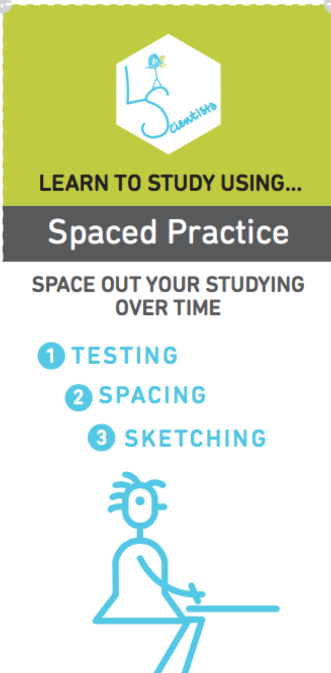
Revision Strategies: How to approach revision
Spaced Practice: Spread out your practice, leaving gaps between revision of the same topic, returning to it and to topics previously revised after increasing periods of time.

Start planning early for exams, and set aside a little bit of time every day. Five hours spread out over two weeks is better than the same five hours all at once.
Review information from each class, but not immediately after class.
After you review information from the most recent class, make sure to go back and study important older information to keep it fresh.
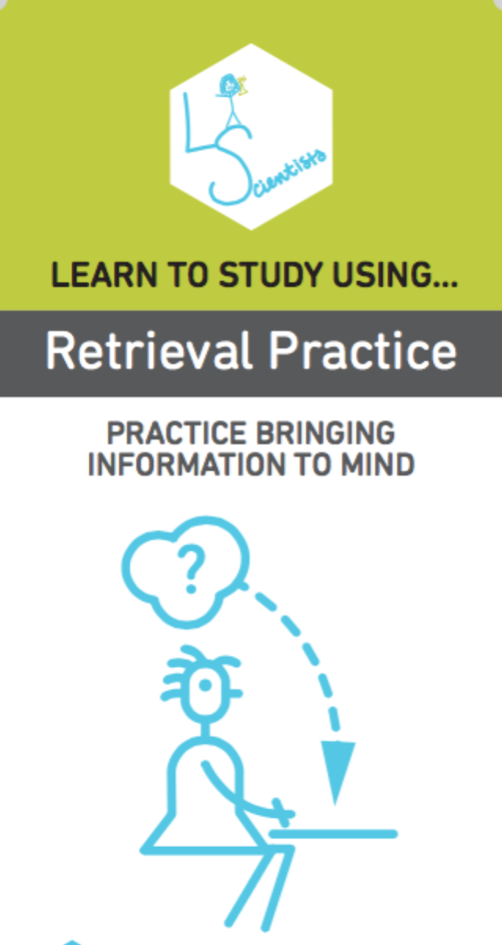
Retrieval practice: Practice retrieving what is in your head that you know about a topic.
Put away your class materials, and write or sketch everything you know. Be as thorough as possible. Then, check your class materials for accuracy and important points you missed.
Take as many practice tests as you can get your hands on. If you don’t have ready-made tests, try making your own and trading with a friend who has done the same.
You can also make flashcards. Just make sure you practice recalling the information on them, and go beyond definitions by thinking of links between ideas.
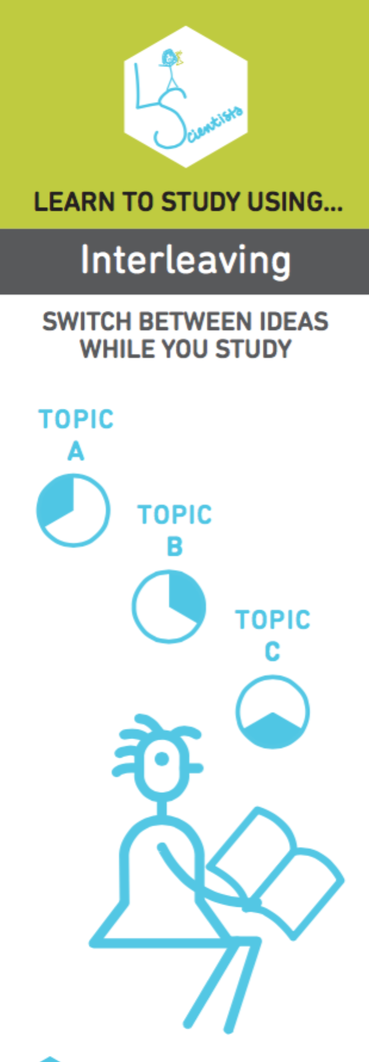

Interleaving: Switch between topics studied in the same revision sessions. This strategy helps you to make links between topics studied.

Don’t study one idea for too long. Don’t spend an entire session on the same topic, but don’t jump about too often either.
Go back over the ideas again in different orders to strengthen your understanding.
Make links between different ideas as you switch between them.

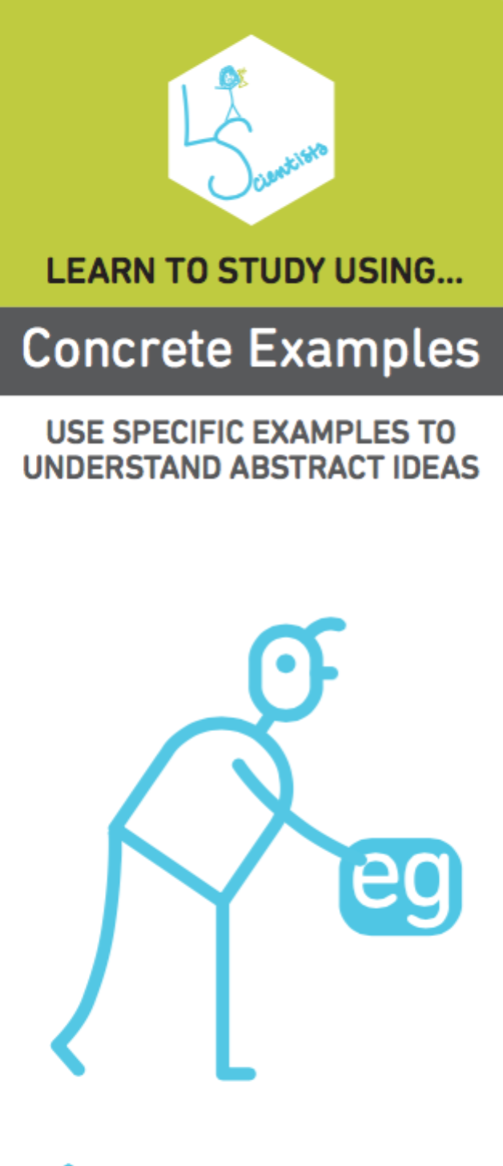
Concrete Examples: Use specific concrete examples. Relevant examples help explain and demonstrate ideas, which helps us to understand them better.

Collect examples your teacher has used, and look in your class materials for as many examples as you can find.
Make the link between the idea you are studying and each example, so that you understand how the example applies to the idea.
Share examples with friends, and explain them to each other for added benefits.

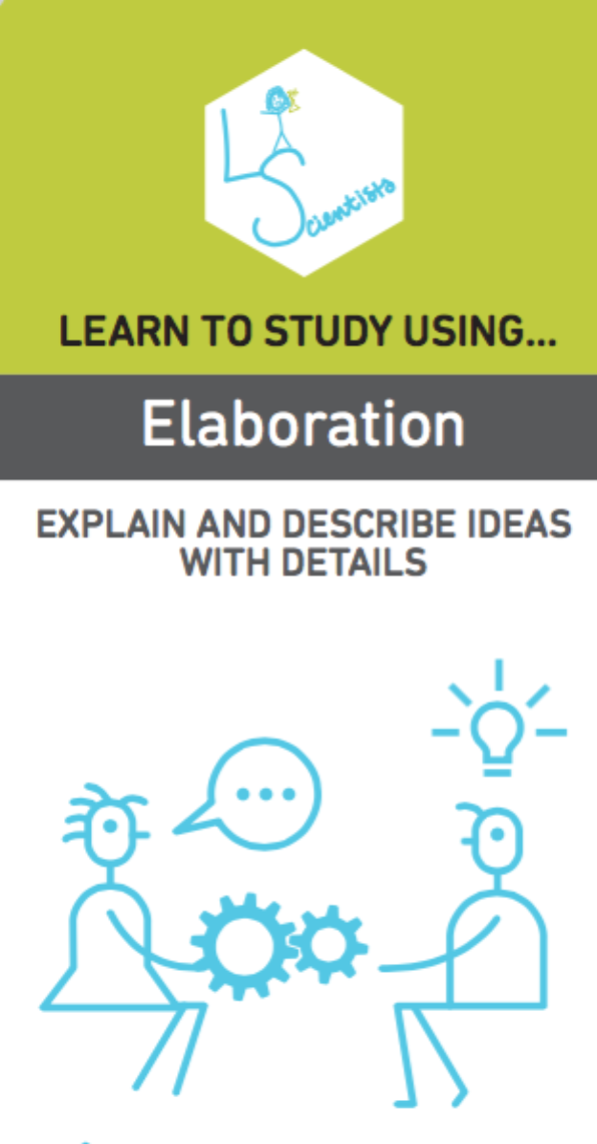
Elaboration: Ask, explain and connect. Ask yourself questions about how and why things work. Explain and describe ideas with as many details as you can. Understand and explain what you know and connect it to previous learning.

Ask yourself questions while you are studying about how things work and why, and then find the answers in your class materials and discuss them with your classmates.
As you elaborate, make connections between different ideas to explain how they work together. Take two ideas and think of ways they are similar and different.
Describe how the ideas you are studying apply to your own experiences or memories. As you go through your day, make connections to the ideas you are learning in class.

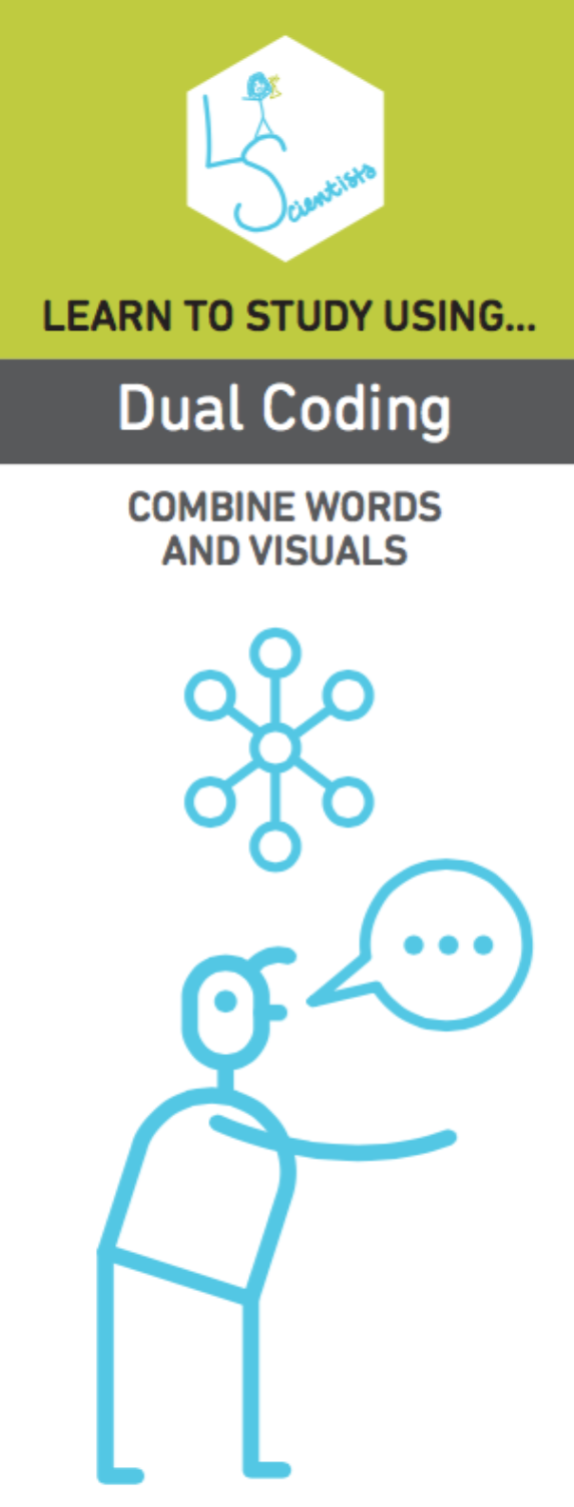
Dual Coding: Combine verbal materials with visuals. The words combining with a picture or diagram gives your brain two ways of re-connecting to the concept later on.
Look at your class materials and find visuals. Look over the visuals and compare to the words.
Look at visuals, and explain in your own words what they mean.
Take information that you are trying to learn, and draw visuals to go along with it.

20 tips for REVing up REVision
- Use colour and pictures in your notes – this makes them more memorable.
- Limit the time of your revision slots and build in rewards to keep you motivated. Try the Pomodoro Technique. There are five basic steps to the technique:
- Decide on the task to be done
- Set the pomodoro timer to a number of minutes (traditionally 25)
- Work on the task until the timer rings
- Take a short break (3-5 minutes)
- Every four "pomodori" take a longer break (15–30 minutes)
- Literacy skills are critical in ALL exams, not just English. Remember to check your spelling, punctuation and grammar.
- Devise a chart, map, plan, grid which shows the key bits of knowledge and the key skills you will need to develop. Map where it fits with the big picture.
- Create timelines of key dates and events
- Use a traffic lights system on a full list of the syllabus to colour bits you feel very confident about (green), less so (yellow) and weak on (red).
- Record notes out loud on your mp3 player and play back to you while in quiet time (on the bus etc)
- Be creative with different ways of explaining a concept:
- Explain the concept to someone else out loud
- Explain it in a spider diagram
- Explain it in a flow chart
- Explain it in a sequence of pictures
- Put post-it notes and revision notes up around your bedroom to constantly absorb the information
- Highlight key parts of text and then turn this into notes (writing things out helps then to stick in your memory)
- Use mnemonics to remember lists or key facts/concepts
- Create a poster of six pictures that summarise a topic – note key words around the picture
- Create true/false cards and test yourself
- Take an exam question and annotate it – showing what the key words
- Do past paper questions, look at the mark schemes for what you have got correct and go over what you got wrong
- Get other people to test you, repeat back to them your notes and the key facts
- Time yourself answering exam questions – managing your time in some exams will be critical
- Use websites where you can test yourself and review key concepts
- Think about PEE in your notes: Point, Explain, Evidence (or Example)
- TALK TO YOUR TEACHERS about what works for each subject.

Time Management
All good work needs planning.
Think about having:
- A short term plan (daily)
- A medium term plan (weekly)
- A long term plan (monthly)

Be realistic
When you first start planning revision you may be over ambitious. Be willing to adapt your plan.
Daily plans-short term
- Not all time is ‘quality’ or ‘high energy’. Think about different times for harder tasks (e.g. in the morning). Lower level maintenance tasks can be done when energy levels are low (e.g. straight after school, before meal times or late at night).
- Don’t forget to plan breaks for relaxation. If you usually go to football/aerobics etc… then still go! As long as you have planned effectively, this is still possible.
- At the end of the day’s revision adjust the revision plan if you need to. If you haven’t managed to get through what you’ve planned or you have got further than expected, this can have an affect on the medium and longer term plans of your revision.

Weekly plans-medium term
- These are designed to give you a bit more of an overview and will help you avoid missing out on subjects or spending too long on one thing.
- Allow a time slot to set out the following week’s plan.

Long-term revision
- Long term revision plans need to accommodate many other demands made on you and will change.
  - Coursework/homework is still happening
  - School goes on
  - Some of you have part-time jobs
- Long term revision plans need to recognise all of these.
- Be realistic: the time you set aside needs to be productive, effective and work!
- Whilst at school, take advantage of all the revision sessions and tasks put on by teachers in different subjects.
- Use their expertise to clarify/reiterate any topic that you don’t quite get. In order to discover what they are, look over your subject materials in the next few weeks before it’s too late.

After school and lunch time revision opportunities
 | Monday | Tuesday | Wednesday | Thursday | Friday
Lunchtime  1.20pm | Art – Rm 7 (LCa)  Foundation Maths– Rm 27 (JUp)  Higher Maths– Rm 43 (KTa)  History (by invitation) – Rm 5 (JJu) | Art – Rm 7 (LCa)  Higher Maths– Rm 46 (NCo)  Computing – Rm 15 (EGe)  RE – Rm 24 (LRa) Drop in session  English – Set 3 Rm 2 (SWa) | Art – Rm 7 (LCa)  Film Studies – Rm 33 (STr)  RE – Rm 3 (DYa) – from Feb half-term)  French Speaking – Rm 12 (BMo)  Combined Biology/Chemistry – Rm 24/25 (SBo and AHe) From Feb Half-term | Art – Rm 7 (LCa)  History – Rm 4 (ADu) | Art – Rm 7 (LCa)  Drama – Rm 45 (MHa)  English - Set 2 - Rm 34 (ESt)
After School  until 5pm | French – Rm 14 (SHT)  Geography – Rm 11 (LFa)) | Higher Maths– Rm 44 (CHd)  Business – Rm 11 (JWI)  English –  Set 4 Rm 33 (GWi) ,  Set 5 Rm 31 (STr)  Set 6 Rm 26 (TGo)  English - Set 2 (by invitation) (ESt) | Foundation Maths– Rm 27 (JUp), 47 (JFe), 26 (SMa)  Computing – Rm 15 (EGe)  English - Set 1 (by invitation) – Rm 30 (JFa)  English - Set 3 – Rm 2 (SWa) | Art – Rm 7 (LCa)  Drama – Rm 45 (MHa)  Biology, Chemistry, Physics (accelerated/triple scientists) – Rm 21/22/42 (SPh/KSa/DMc)  Physics Combined – Rm 24 (SRo) From Feb Half-term | Higher Maths– Rm 43 (KTa) + Rm 46 (NCo)  French – Rm 14 (by invitation) (SHT)
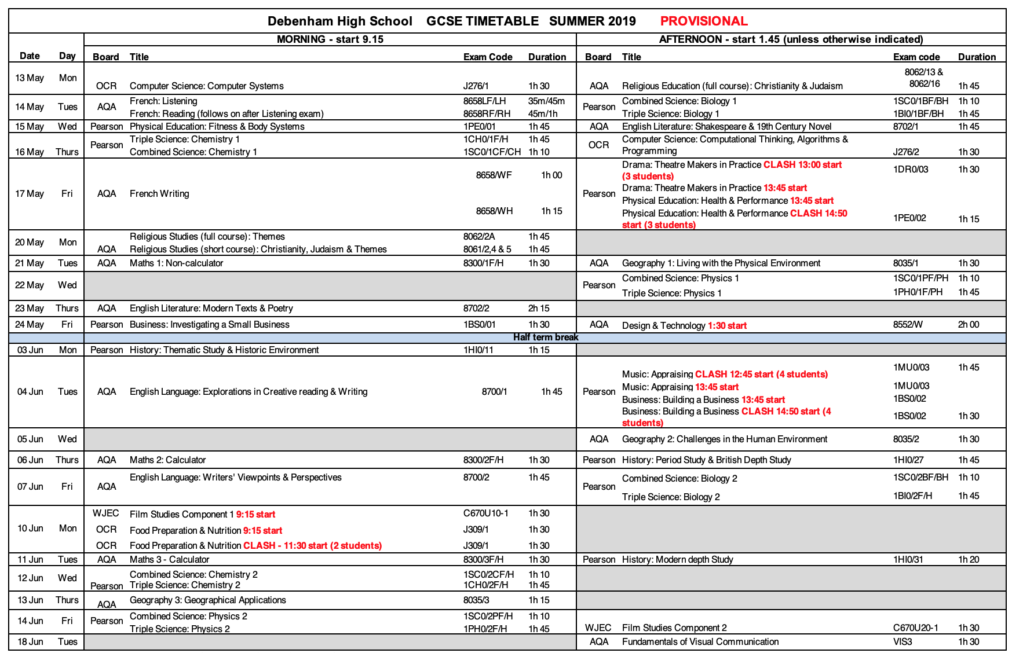

Weekly Revision Plan

Week Commencing: Monday 18 February HALF TERM

 | Monday | Tuesday | Wednesday | Thursday | Friday | Saturday | Sunday
9-10
10-11
11-12
12-1
1-2
2-3
3-4
4-5
5-6
6-7
7-8
8-9
9-10

Weekly Revision Plan

Week Commencing: Monday 25 February HALF TERM

 | Monday | Tuesday | Wednesday | Thursday | Friday | Saturday | Sunday
9-10
10-11
11-12
12-1
1-2
2-3
3-4
4-5
5-6
6-7
7-8
8-9
9-10

Weekly Revision Plan

Week Commencing: Monday 4 March

 | Monday | Tuesday | Wednesday | Thursday | Friday | Saturday | Sunday
9-10
10-11
11-12
12-1
1-2
2-3
3-4
4-5
5-6
6-7
7-8
8-9
9-10

Weekly Revision Plan

Week Commencing: Monday 11 March

 | Monday | Tuesday | Wednesday | Thursday | Friday | Saturday | Sunday
9-10
10-11
11-12
12-1
1-2
2-3
3-4
4-5
5-6
6-7
7-8
8-9
9-10

Weekly Revision Plan

Week Commencing: Monday 18 March

 | Monday | Tuesday | Wednesday | Thursday | Friday | Saturday | Sunday
9-10
10-11
11-12
12-1
1-2
2-3
3-4
4-5
5-6
6-7
7-8
8-9
9-10

Weekly Revision Plan

Week Commencing: Monday 25 March

 | Monday | Tuesday | Wednesday | Thursday | Friday | Saturday | Sunday
9-10
10-11
11-12
12-1
1-2
2-3
3-4
4-5
5-6
6-7
7-8
8-9
9-10

Weekly Revision Plan

Week Commencing: Monday 1 April

 | Monday | Tuesday | Wednesday | Thursday | Friday | Saturday | Sunday
9-10
10-11
11-12
12-1
1-2
2-3
3-4
4-5
5-6
6-7
7-8
8-9
9-10

Weekly Revision Plan

Week Commencing: Monday 8 April EASTER HOLIDAYS

 | Monday | Tuesday | Wednesday | Thursday | Friday | Saturday | Sunday
9-10
10-11
11-12
12-1
1-2
2-3
3-4
4-5
5-6
6-7
7-8
8-9
9-10

Weekly Revision Plan

Week Commencing: Monday 15 April EASTER HOLIDAY

 | Monday | Tuesday | Wednesday | Thursday | Friday | Saturday | Sunday
9-10
10-11
11-12
12-1
1-2
2-3
3-4
4-5
5-6
6-7
7-8
8-9
9-10

Weekly Revision Plan

Week Commencing: Monday 22 April

 | Monday | Tuesday | Wednesday | Thursday | Friday | Saturday | Sunday
9-10
10-11
11-12
12-1
1-2
2-3
3-4
4-5
5-6
6-7
7-8
8-9
9-10

Weekly Revision Plan

Week Commencing: Monday 29 April

 | Monday | Tuesday | Wednesday | Thursday | Friday | Saturday | Sunday
9-10
10-11
11-12
12-1
1-2
2-3
3-4
4-5
5-6
6-7
7-8
8-9
9-10

Weekly Revision Plan

Week Commencing: Monday 23 April

 | Monday | Tuesday | Wednesday | Thursday | Friday | Saturday | Sunday
9-10
10-11
11-12
12-1
1-2
2-3
3-4
4-5
5-6
6-7
7-8
8-9
9-10

Weekly Revision Plan

Week Commencing: Monday 30 May

 | Monday | Tuesday | Wednesday | Thursday | Friday | Saturday | Sunday
9-10
10-11
11-12
12-1
1-2
2-3
3-4
4-5
5-6
6-7
7-8
8-9
9-10

Weekly Revision Plan

Week Commencing: Monday 7 May (Bank Holiday) FIRST EXAMS THIS WEEK

 | Monday | Tuesday | Wednesday | Thursday | Friday | Saturday | Sunday
9-10
10-11
11-12
12-1
1-2
2-3
3-4
4-5
5-6
6-7
7-8
8-9
9-10

Weekly Revision Plan

Week Commencing: Monday 14 May MANY EXAMS THIS WEEK

 | Monday | Tuesday | Wednesday | Thursday | Friday | Saturday | Sunday
9-10
10-11
11-12
12-1
1-2
2-3
3-4
4-5
5-6
6-7
7-8
8-9
9-10

Weekly Revision Plan

Week Commencing: Monday 21 May MANY EXAMS THIS WEEK

 | Monday | Tuesday | Wednesday | Thursday | Friday | Saturday | Sunday
9-10
10-11
11-12
12-1
1-2
2-3
3-4
4-5
5-6
6-7
7-8
8-9
9-10

Weekly Revision Plan

Week Commencing: Monday 28 May HALF TERM

 | Monday | Tuesday | Wednesday | Thursday | Friday | Saturday | Sunday
9-10
10-11
11-12
12-1
1-2
2-3
3-4
4-5
5-6
6-7
7-8
8-9
9-10

Weekly Revision Plan

Week Commencing: Monday 4 June MANY EXAMS THIS WEEK

 | Monday | Tuesday | Wednesday | Thursday | Friday | Saturday | Sunday
9-10
10-11
11-12
12-1
1-2
2-3
3-4
4-5
5-6
6-7
7-8
8-9
9-10

Weekly Revision Plan

Week Commencing: Monday 11 June MANY EXAMS THIS WEEK

 | Monday | Tuesday | Wednesday | Thursday | Friday | Saturday | Sunday
9-10
10-11
11-12
12-1
1-2
2-3
3-4
4-5
5-6
6-7
7-8
8-9
9-10

Weekly Revision Plan

Week Commencing: Monday 18 June LAST EXAM THIS WEEK

 | Monday | Tuesday | Wednesday | Thursday | Friday | Saturday | Sunday
9-10
10-11
11-12
12-1
1-2
2-3
3-4
4-5
5-6
6-7
7-8
8-9
9-10

Daily Plan

Use this page, or one like it to set out more detail on what you are covering on a given day.

Subject | Topic | Details
Subject | Topic | Details
Subject | Topic | Details

Daily Plan

Use this page, or one like it to set out more detail on what you are covering on a given day.

Subject | Topic | Details
Subject | Topic | Details
Subject | Topic | Details

Daily Plan

Use this page, or one like it to set out more detail on what you are covering on a given day.

Subject | Topic | Details
Subject | Topic | Details
Subject | Topic | Details

Daily Plan

Use this page, or one like it to set out more detail on what you are covering on a given day.

Subject | Topic | Details
Subject | Topic | Details
Subject | Topic | Details

Daily Plan

Use this page, or one like it to set out more detail on what you are covering on a given day.

Subject | Topic | Details
Subject | Topic | Details
Subject | Topic | Details

Exam Terminology
Exam questions usually involve some of the following trigger words or phrases. Make sure you know what they mean so that you can show what you know and aren’t stumped by the wording of a question.
Account for explain, give reasons for something
Analyse show relationships between parts and the whole e.g. poem, text, pattern on a map, causes of an event
Annotate label with notes, not just words or phrases but explanations
Argue give reasons for or against something, give evidence
Assess weigh up, evaluate
Case study give an example of something that you have been studying
Comment on give views on, backed up with evidence
Compare state similarities and mention differences
Contrast mention differences but comment on similarities
Criticise give a well-argued judgement or opinion
Define give the meaning of something, say what its characteristics
Discuss weigh up both sides of an argument, give strengths and weaknesses of different options
Explain say how or why something is like it is – give reasons
Evaluate work out
Hypothesis a theory – something to test out
Identify give key features or characteristics of something
Illustrate give examples
Interpret explain the meaning of something or why it happens
Justify argue a case for something
Outline give the main features of something
Prove show how this always works, explain your reasoning
Relate narrate, show connections between
Review go over the evidence, go over what is there and assess it
State explain in a clear and sharp form, give facts
Summarise go over the main points again concisely
Trend a change over time

Exam Technique
Right place, right time
Make sure you know which exam is on each day, what topics you need to revise and what equipment you need to take. Most exams require you to write in blue or black pen. Bring the minimum with you; coats, bags and mobile phones are not allowed in the exam room.
Get to the exam room in plenty of time so that you aren’t rushed. Stay calm - try not to get into conversations about what you revised/not revised. You don’t want anyone knocking your confidence at this stage. It’s too late to worry and you can only do your best.
Invigilator instructions
Listen carefully to the invigilators- they will advise you of any changes to the paper. Important: Make sure you are sitting for the correct tier of paper.
Check the front cover for information about the length of time, the number of questions, equipment you can use etc…
READ the questions carefully
Read and re-read each question. Use a highlighter pen or marker to highlight or underline important words. These might be
- Trigger or instruction words like: Describe…/ Explain…/ Evaluate…
- Important subject specific words for which you need to think about the meaning
- Pitfall to look out for, e.g. in Geography “an economically developed country” is different from “an economically developing country”.

Timings and Marks
Always look in the margin for the mark allocation (how many marks per question). This will help you plan your time. Allow more time on questions worth more marks.
Allow time to read the questions. If there is a choice, make sure you are able to do all the parts (or most of them) of the question you have chosen.
Check your working
Check you haven’t overlooked parts of any question. It’s easy to miss bits in a rush to get to the end.

Techniques for making notes
Mind Mapping
Mind mapping is a useful way of visualizing important points/sections and also linking them.
Handy tips:
- Use words and pictures
- Try to include as much information as possible
- Be selective about the words/phrases that you use, i.e. don’t go into too much detail.

Example:

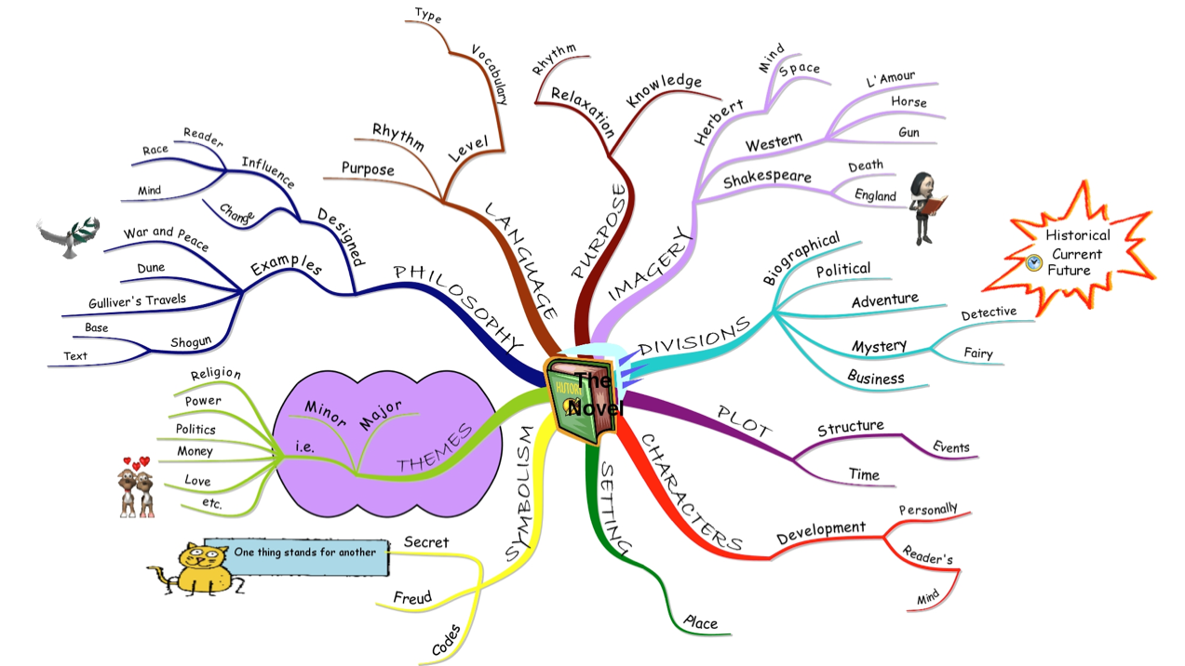

Key Facts Cards
Key fact cards are ways of categorizing different topics
Handy Tips
- Use different colour cards for different topics/subjects
- Use headings and bullet points
- Add simple diagrams
- Use a highlighter pen/coloured pencils to separate sections or make important bits stand out.
Topic
Pythagoras’ Theorem
Right-angled triangles
a² + b² = c²
C is the hypoteneuse – the longest side
Example

7
3
x
Find x
a² + b² = c²
3² + 7² = c²
9 + 49 = c²
58 = c²
√58 = c Remember to √
7.62 = c (rounded to 2 significant figures – after the decimal point)

Point – Explain – Evidence (or Example)
Think about using this way of writing when you make notes.
Topic: Geography: River formations

POINT
Feature – Meander – a large bend, especially in the middle or lower stages of a river course.
EXPLAIN
The results of lateral corrasion which becomes dominant over vertical corrasion as the gradient in the river decreases.
Erosion on the outer bank causes undercutting and river cliff. Slack water on inner bank causes deposition and a bank of sediment called a meander scroll is produced.

EVIDENCE

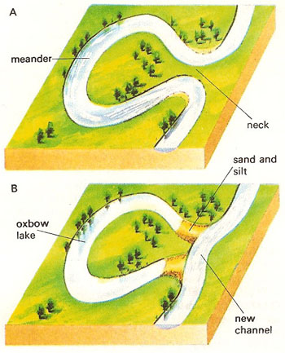
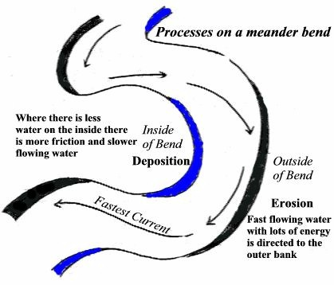
Mnemonics
Mnemonics are a way of using initial letters to remember important terms or phrases.
Example: to remember the colours of the rainbow
R O Y G B I V
‘Richard of York gave battle in vain’
Red- Orange- Yellow- Green- Blue- Indigo-Viole
Stage 1
Choose key words from a topic of your choice
Eg: Proteins (Food Tech)
Carbon
Hydrogen
Oxygen
Phosphors
Nitrogen

Stage 2
Use the first letter of each word to make a sentence or word that you can remember
Eg
Chops & N

(funny sentences are easier to remember)

Using images to aid your memory
Take this psychology study: Kobasa (1979), Evidence for the relationship between HARDINESS and Coronary Heart Disease
PROCEDURE
Type of experiment: | Natural experiment using correlation analysis
Research Design: | Independent groups
Sampling method: | Volunteer sampling

- Kobasa interviewed 800 white, middle-class, male managers

- Participants completed three questionnaires: a personality questionnaire; the Social Readjustment Rating Scale (a questionnaire to identify stressful events) over three years; and a measure of their illness over three years.
The participants could be split into two groups based on the results of the illness questionnaire:
  - those who had become ill more than average
  - those who had become ill less than average
FINDINGS
- According to the personality questionnaire, those who became ill less than average showed the same cluster of personality factors that helped them cope with stress:
  - Control: Hardy individuals have a strong sense of personal control. They have direction in life and feel that they are in control of their lives and can influence their situation, rather than being controlled by outside factors
  - Commitment: Hardy individuals are involved in what they do. They are committed to their work and personal relationships, and have a strong sense of purpose
  - Challenge: Hardy individuals view potentially stressful situations as a challenge to be overcome, rather than a problem or threat. They enjoy change as an opportunity for development
- Together, these characteristics are described as Hardiness, and a person who shows them is known as Hardy
CONCLUSIONS
- Hardiness – showing control, commitment and viewing life as a challenge – allows us to cope with stress in a better way. This means that we are less likely to suffer from stress-related illnesses such as Coronary Heart Disease.
- Those who DO NOT show hardiness are more likely to develop CHD because their long-term stress response increased their heart rate and blood pressure due to the release of adrenaline and noradrenaline (stress hormones)
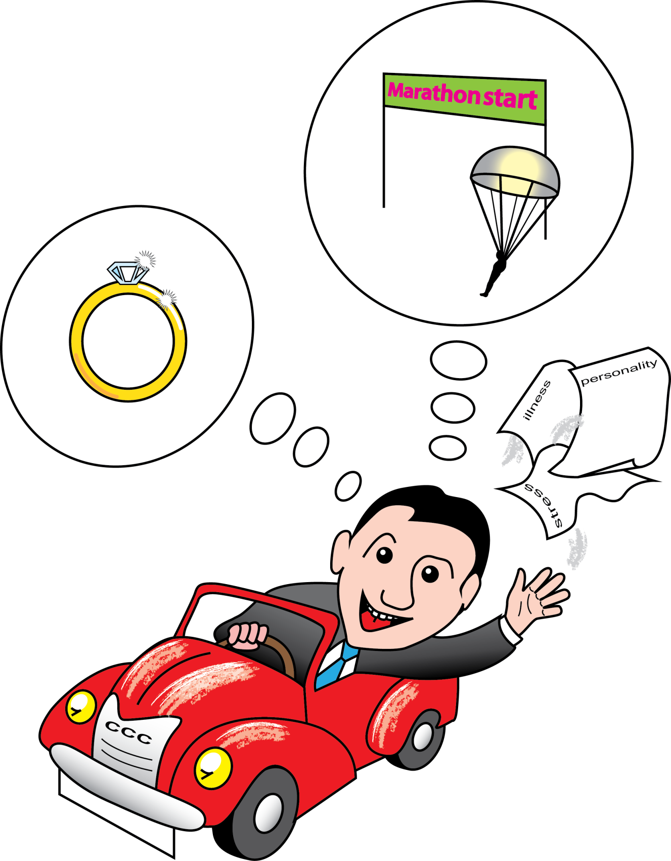
Avoiding stress
Warning signs
The build-up to an examination is a stressful time and stress can be both productive and destructive. You have to ensure that you can recognise, control and use it to your advantage. Easier said than done for some people, but all of us have suffered from the destructive elements of stress at some stage! It can show itself in some of the following ways.
- Tiredness, irritability, feeling unwell or ill at ease
- Loss of appetite, unable to sleep
- A constant sense of anxiety and worry
- Panic attacks, headaches
- Inability to focus, concentrate on or complete tasks
- Inertia and sense of paralysis; unable to do what needs to be done, putting things off, avoiding problems
- Self-doubt, negative thoughts, giving up

Coping
There are strategies for controlling and channeling these symptoms. Try to construct a framework where you:
- plan your time – if you know what you are doing and when you will be less stressed about things
- are aware of your strengths and weaknesses and attempt to do something about the weakness
- don’t judge yourself by other people saying what they have or haven’t done, focus on what you are doing and what you know (especially the morning of the exam)
- remain in control rather than letting your anxiety take over
- identify what is causing the concern and tackle the cause; most problems have solutions if you face them positively
- seek help and share your worries with someone; even talking about a problem helps to dissipate the stress it is causing and can open the way to a solution
- practice breathing and relaxation techniques, take some physical exercise; do something different but strongly focused to take your mind temporarily off revision and examinations
- leave some time and diversion to wind down at the end of the day before you go to bed, so that you are not trying to go to sleep with unanswered thoughts buzzing around in your head
- live a regular and moderate routine; eat, drink and sleep normally and with a healthy routine (YES 8 hours a night is what you should have!), get some exercise, avoid caffeine and sugar and other “energy” supplements
- make lists to tick off so that you can identify your progress
- congratulate yourself for what you have achieved
- keep things in perspective.
Personality traits and stress

I must get things finished once started | 1 2 3 4 5 6 7 | I don't mind leaving things temporarily unfinished
I am highly competitive | 1 2 3 4 5 6 7 | I am not competitive
I am always in a hurry | 1 2 3 4 5 6 7 | I am never in a hurry, even when pressured
I am uneasy when waiting | 1 2 3 4 5 6 7 | I am able to wait calmly
I am always going at full speed | 1 2 3 4 5 6 7 | I am easy going
I try to do more than one thing at a time. What's next? | 1 2 3 4 5 6 7 | I take one thing at a time
I want recognition from others for a job well done | 1 2 3 4 5 6 7 | I am concerned with satisfying myself and not others
I am fast at doing things | 1 2 3 4 5 6 7 | I am slow at doing things
I have few interests | 1 2 3 4 5 6 7 | I have a large number of interests
I often set my own deadlines | 1 2 3 4 5 6 7 | I never set my own deadlines
I always feel responsible | 1 2 3 4 5 6 7 | I feel limited responsibility
Quantity is more important | 1 2 3 4 5 6 7 | I never judge things in terms of quantity, just quality
I am very precise and careful about detail | 1 2 3 4 5 6 7 | I am not very precise

Useful websites
Use this page to note down useful websites for different subjects.
English | Maths  www.mymaths.co.uk | Science
Religious Education

And finally ……

Remember how proud we are of how far you have come already and we are here to help.

